Lab 2 – Alexander Stradnic – 119377263

Task 1

Main memory size : 4MB
Page size : 4KB

No. of blocks | No. of Pages | Size (KB)
32 | 2 | 256
16 | 4 | 256
16 | 8 | 512
16 | 16 | 1024
16 | 32 | 2048

Memory Allocation : First Fit – this will use the first block that can fit the process requesting space
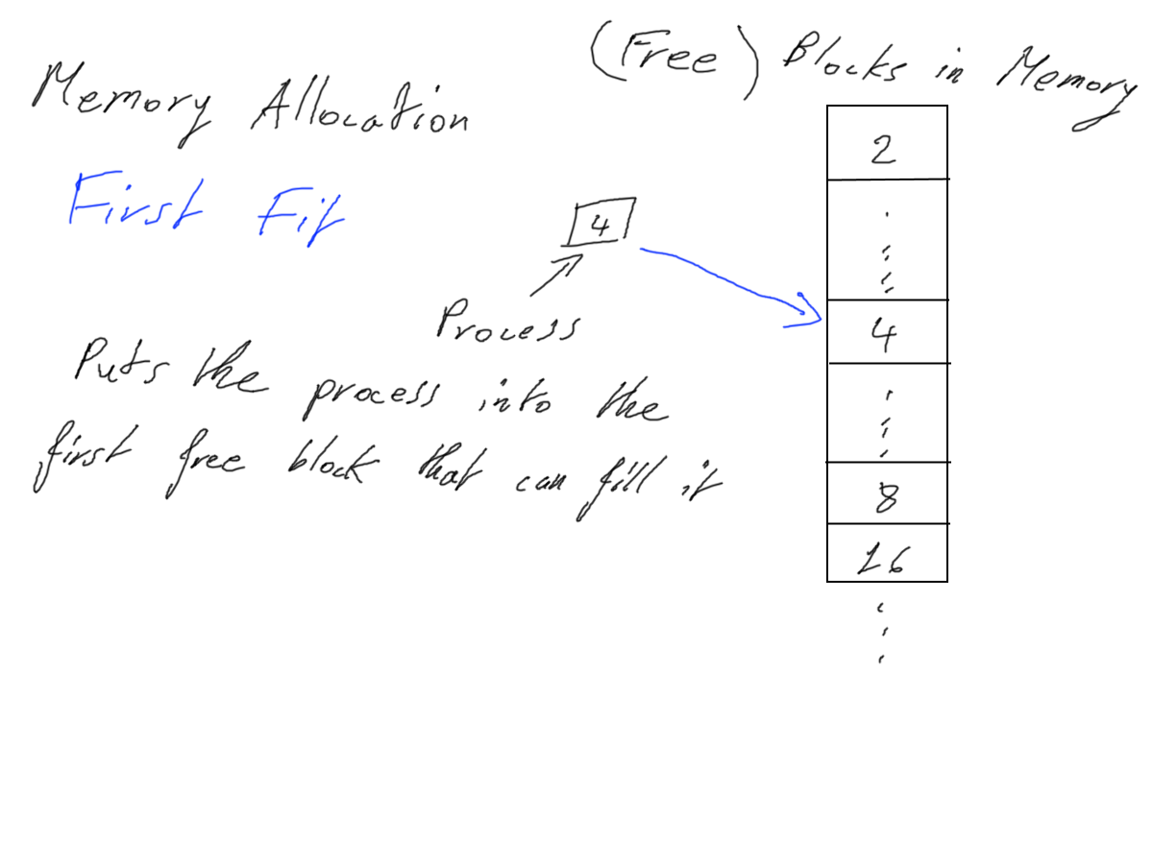
Page Replacement Algorithm : Second Chance – this will replace the oldest block if it hasn’t been accessed recently
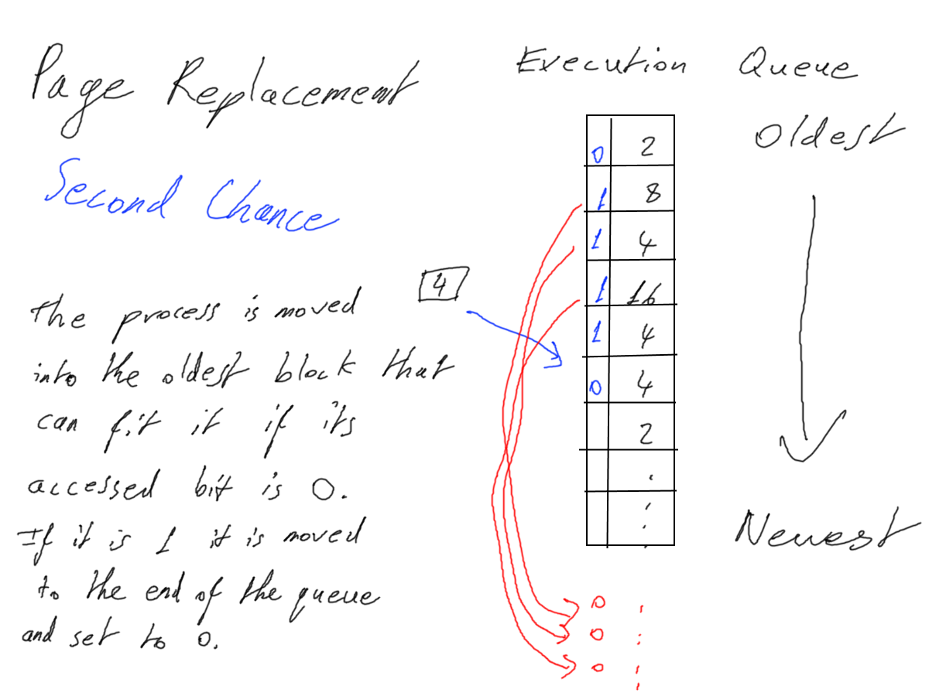
Space : Linked List
Memory requests : Queue

Task 2

requests := [List of Processes to be moved to main memory]

class Block:
#properties
pages := No of pages
next := Next block in Space
prev := Previous block in Space
process := The process itself
accessed := 1 if the process was accessed recently, else 0, used in the Second Chance PRA

class Space:
exec_list := A queue in which processes are sorted by their time of execution; the oldest being the first process
first := Block(pages=2) # A DLL made up of blocks from 2 pages to 32 pages
function add(process):
block = this.first
while True:
if not block.process and process.pages <= block.pages:
block.process = process
this.exec_list.append(block)
break
if not block.next:
this.page_replace(process)

function page_replace(process):
for block in this.exec_list:
if block.pages >= process and block.accessed == 0:
block.process = process
this.exec_list.append(this.exec_list.pop(block))
return True
return False

function process_requests():
while True:
process = requests[0]
requests = requests[1::]
success = space.page_replace(process)
if not success:
requests.append(process)

